|  |  |
| --- | --- |
| Course Name | ITD-2313 Script Programming |
| Instructor | M. Schnell |
| Student Name | Bridgette Johnson |
| Due date | 2/12/2023 |
| Grade | <grade earned here> |
| Grading Comments | <instructor comments here> |

# Textbook Exercises for Week 5

Page 78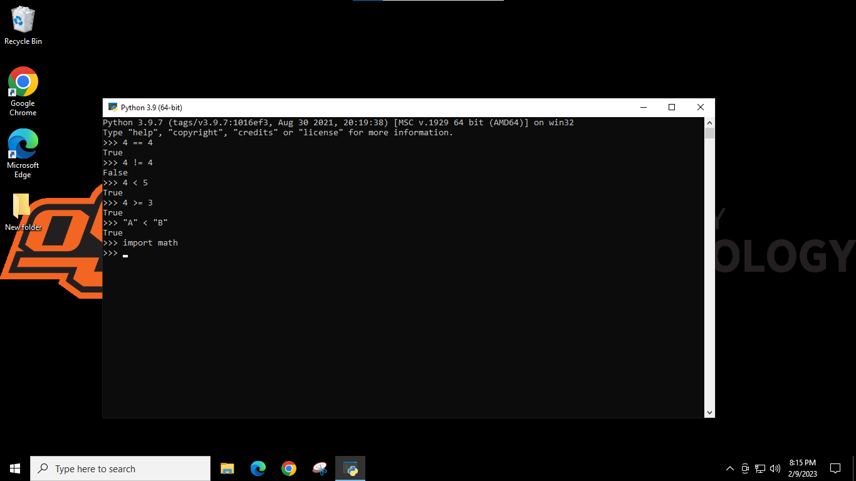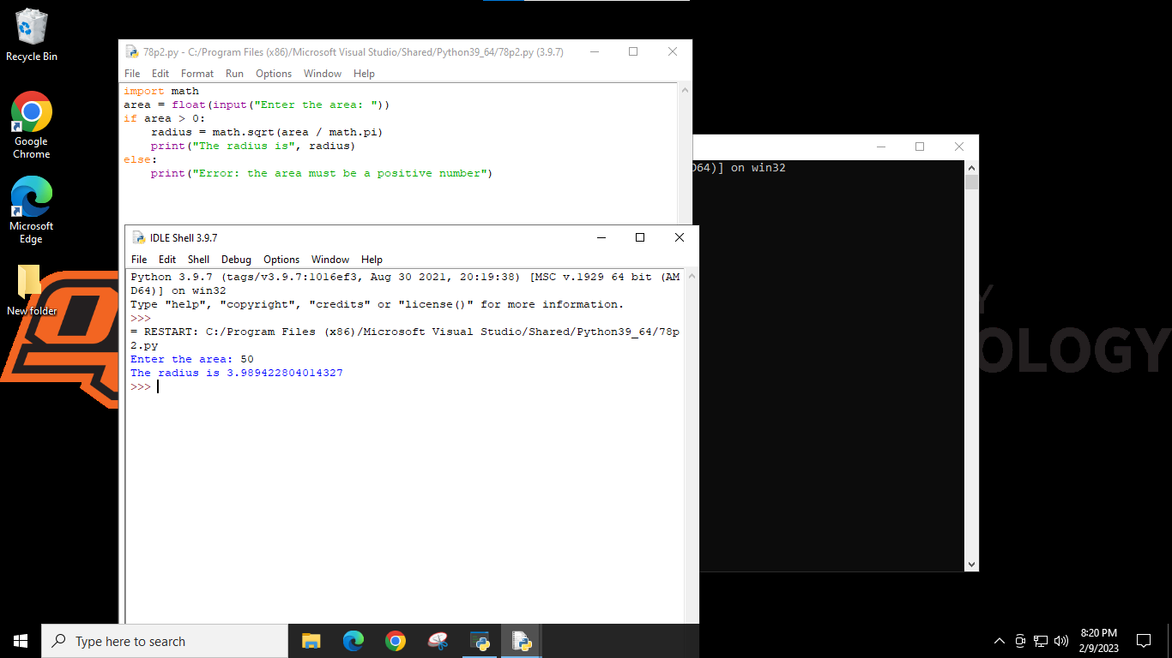

Page 79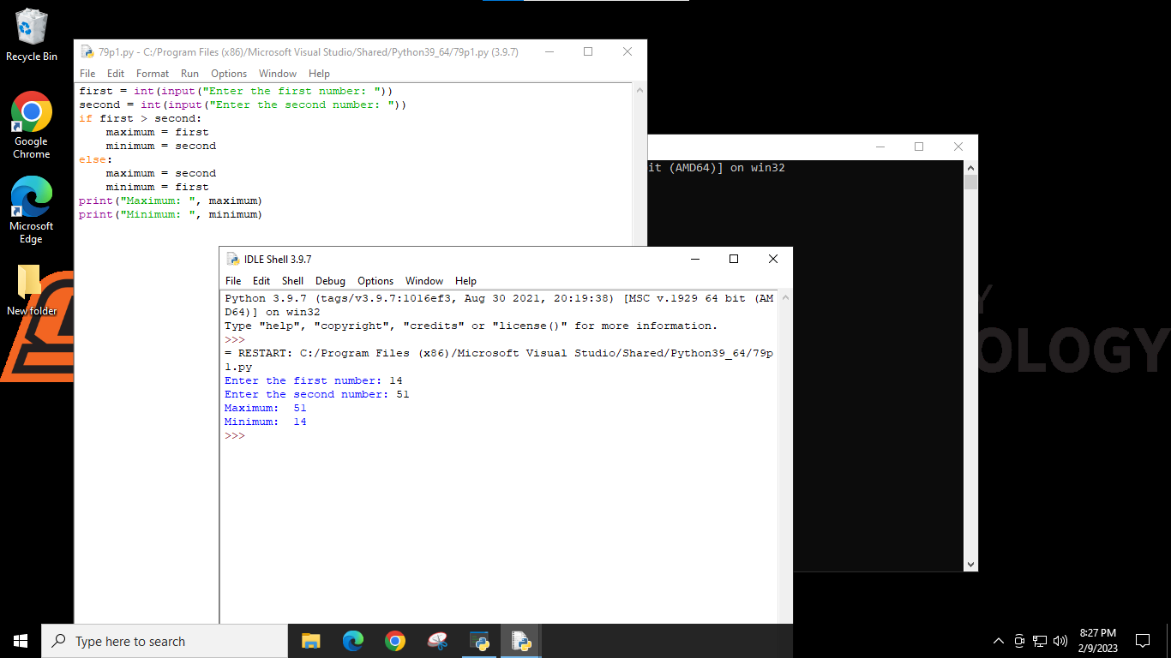

Page 81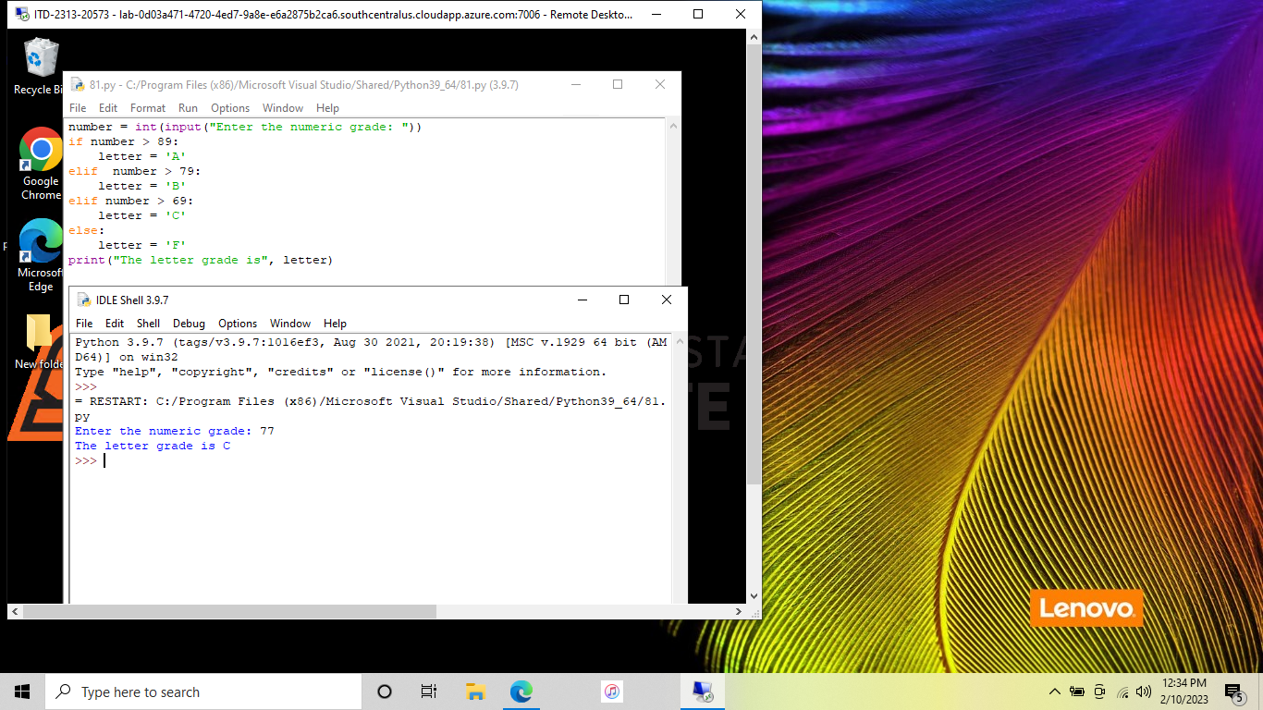

Page 91